**Installation Guide for ALPHA release v.0.1.0**

1. Once you download the package from web, the .dll files might be blocked. In order to enable the dlls, please **right click** on each file and click **Properties**. Under “**General**” tab, on the bottom check if there is Security item appears, then Click **Unblock** button to enable the dlls.

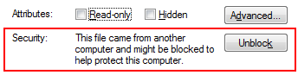

1. Before launch the Dynamo 0.7., copy the dll file under the folder “./**dlls/EnergyAnalysisForDynamo_UI**” into “**C:\Program Files\Dynamo 0.7\Revit_2014\nodes**”
2. Now you need to importing EnergyAnalysisForDynamo library into Dynamo. Open Dynamo 0.7, go to “**Libraries**” tab and click “**Import Library…”** and select the “**EnergyAnalysisForDynamo.dll**” from “**dlls/EnergyAnalysisForDynamo**” folder.

Note: You need to repeat this step #3 every time you open a new instance of Dynamo.



